WHAT CAN THE TEACHER DO?
Hello _______ Sensei!
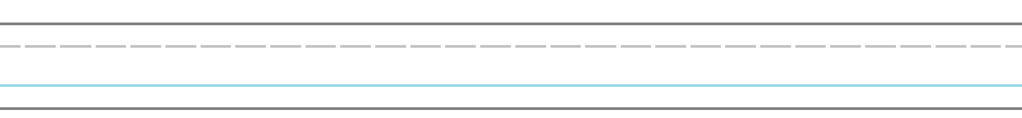
Can you _____________?
What _____ do you like?
How are you?

Can you _____________?



What can’t you do?


Thank you!

